**Assignment 03 – Drupal 8 CMS Website (Media Library - FlexSlider)**

**Instructions for completing template:**Replace **[bracketed red text]** with the requested information or screen capture.  
Replace **bracketed red text with black text** and then remove the brackets.  
Do not include full screen shot images, or full screen shots that are reduced in size. Use a snippet tool to capture parts of the screen and insert those images into the template.  
Do not remove tags from this template. Please answer all questions.  
**Please do not alter the formatting or delete parts of this template.**  
Assignment questions are not as detailed as activity questions.   
The assignment is where you demonstrate understanding of the material.

**Part A: Student Information**

1. **Student Name: Abel Marin [A01]**
2. **Class Designation: Remote [A02]**
3. **Student Contact Information: marinabe1416@gmail.com [A03]**
4. **What day and date did you start this assignment: Thursday March 12, 2020 [A04]**

**Go back to the instructions and begin work on part B.**

**Part B: Create 1 Shared Web Host Drupal 8 CMS Website**

(1) Shared Web Host Drupal 8 CMS Site Information:

Shared Web Host Name: [SiteGround] [B01]  
Shared Web Host Site Admin Username: [amarin13@mail.depaul.edu] [B02]   
Shared Web Host Site Admin Password: [Dbeu!315] [B03]  
Domain Name: [abelm.sgedu.site] [B04]  
Website Admin Username: [**ajmarin**] [B05]  
Website Admin Password: [Sn&TDRe$q0] [B06]  
Database Name: [drup109] [B07]  
Table Prefix: [dro5_] [B08]  
Drupal CMS Website URL: [http://abelm.sgedu.site/assignment10] [B09]

-OR-

(2) Pantheon – Drupal 8 CMS Site Information:

**Assignment Website Site Name:** **[Site Name here] [B01]**

**WEBSITE Admin Username:** **[Admin Username here] [B02]**

**WEBSITE Admin Password:** **[Admin Password here] [B03]**

**Pantheon Drupal 8 CMS Frontend Website URL:** **[Frontend website URL here] [B04]**

**Go back to the instructions and begin work on part C.  
  
Part C: Media**

1. **SCREEN CAPTURE OF Admin toolbar enabled on the Extend page   
   Admin toolbar > Extend, Filter for Admin [C01]  
   [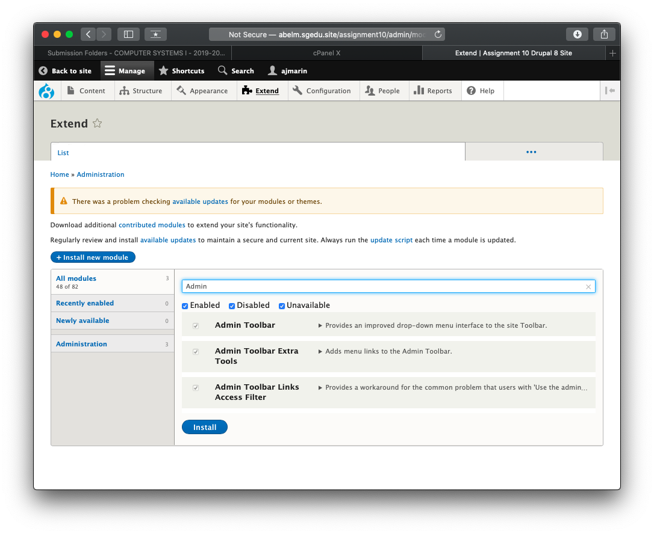]**
2. **SCREEN CAPTURE OF Admin toolbar enabled on the Extend page   
   Admin toolbar > Extend, Filter for Module [C02]  
   [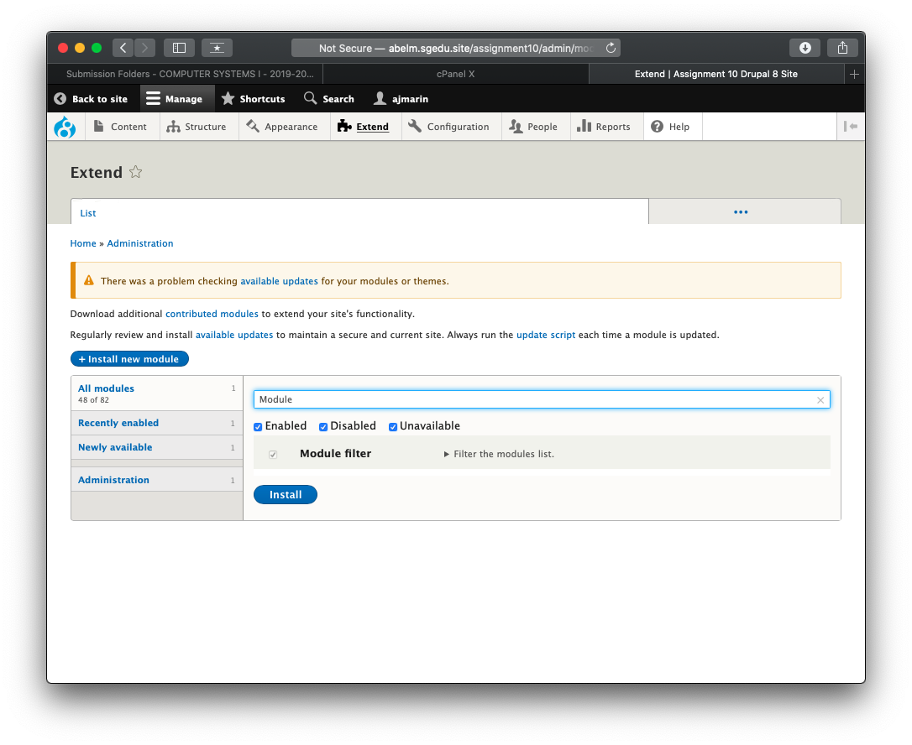]**
3. **SCREEN CAPTURE OF Media and Media modules enabled on the Extend page   
   Admin toolbar > Extend, Filter for Media [C03]  
   [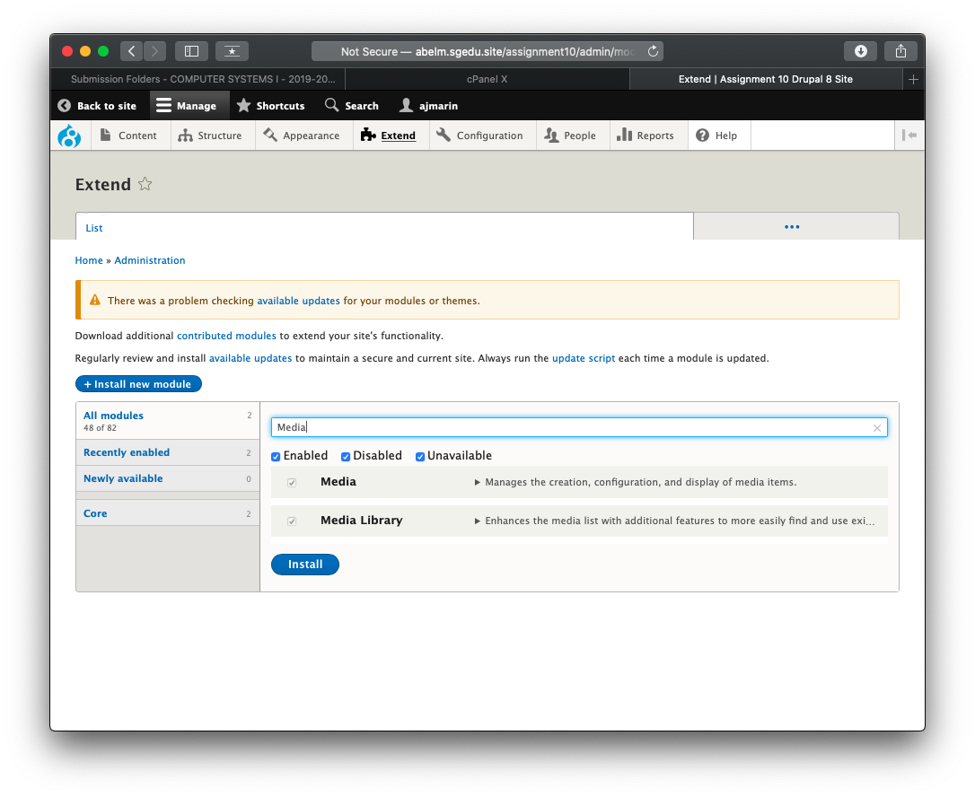]**
4. **SCREEN CAPTURE OF CONTENT Media page listing all uploaded media files  
   Admin toolbar > Content > Media [C04]  
   [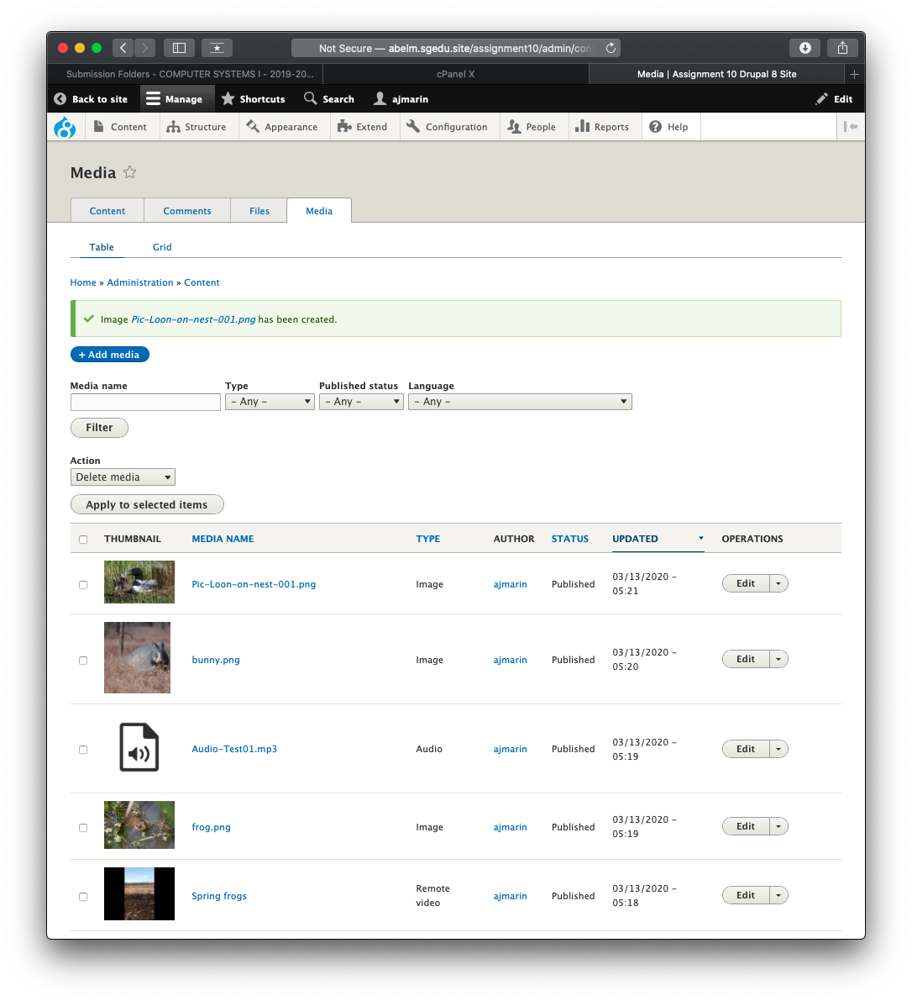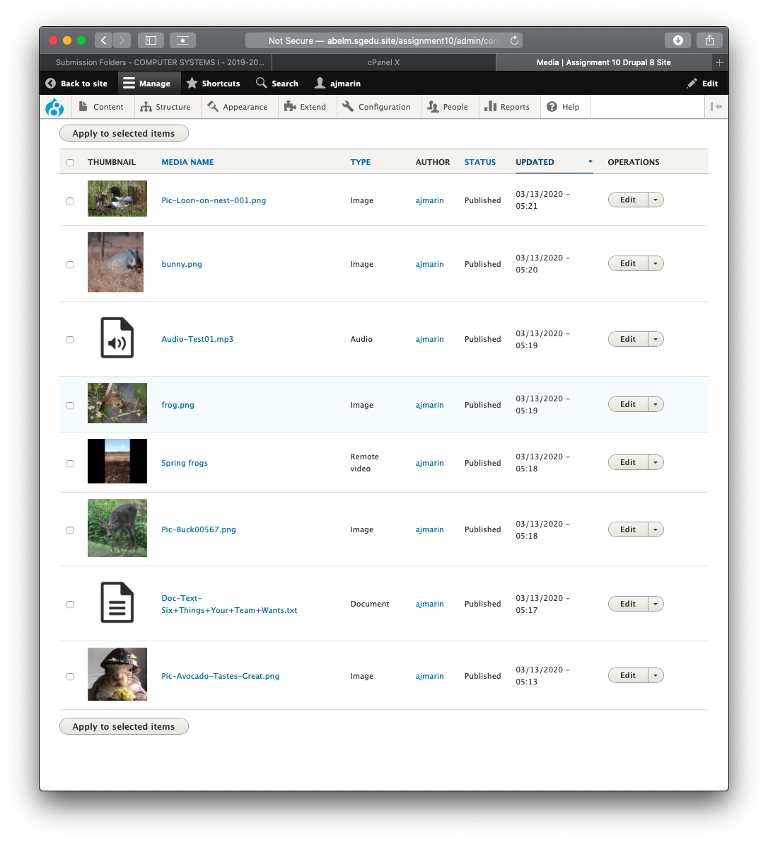]**

**Go back to the instructions and begin work on part D.**

**Part D: Create new custom content type Media record**

1. SCREEN CAPTURE of the **“Media record” content type structure**   
   Admin toolbar > Structure > Content types, select Edit for the “Media record” item  
   **[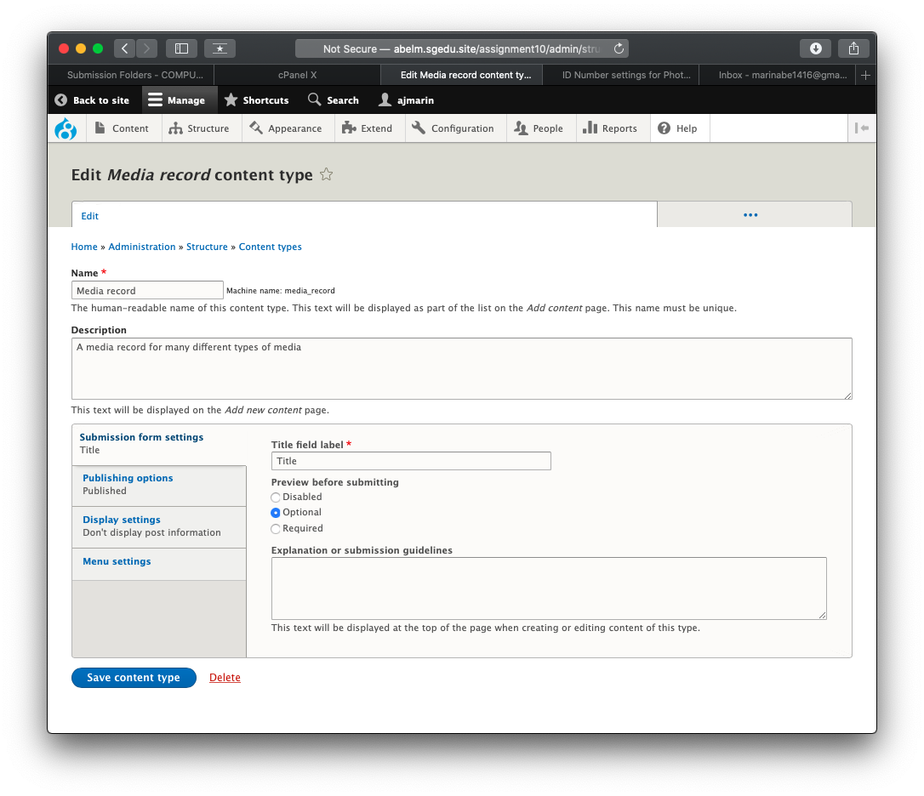] [D1.1]**

**[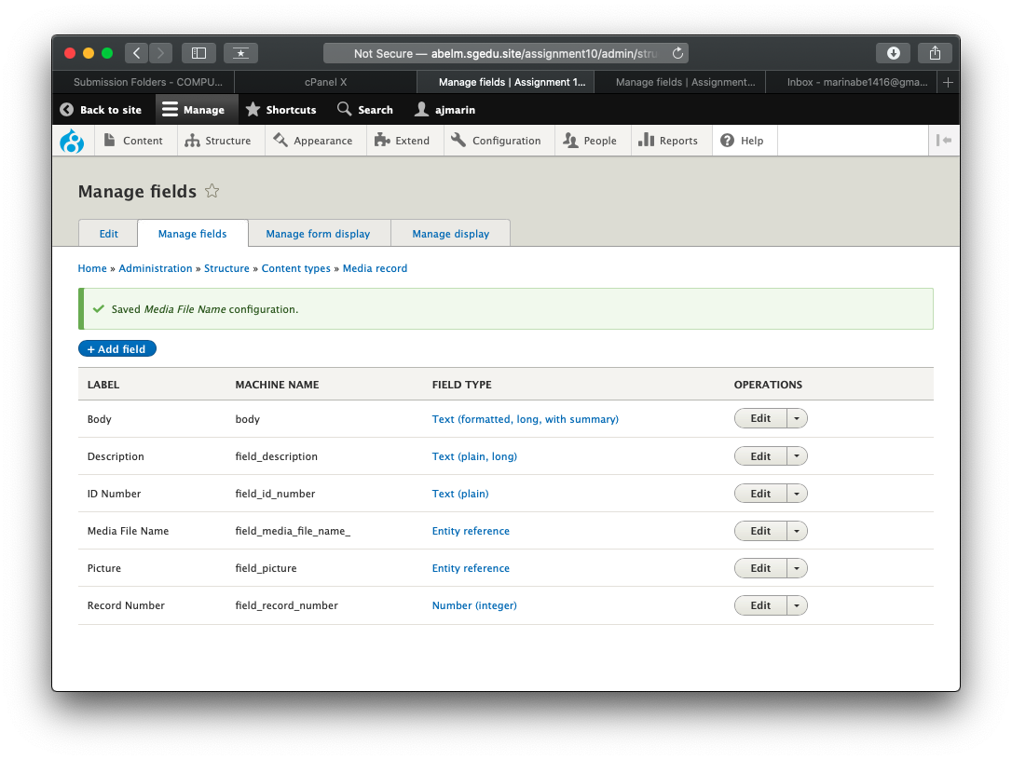] [D1.2]  
[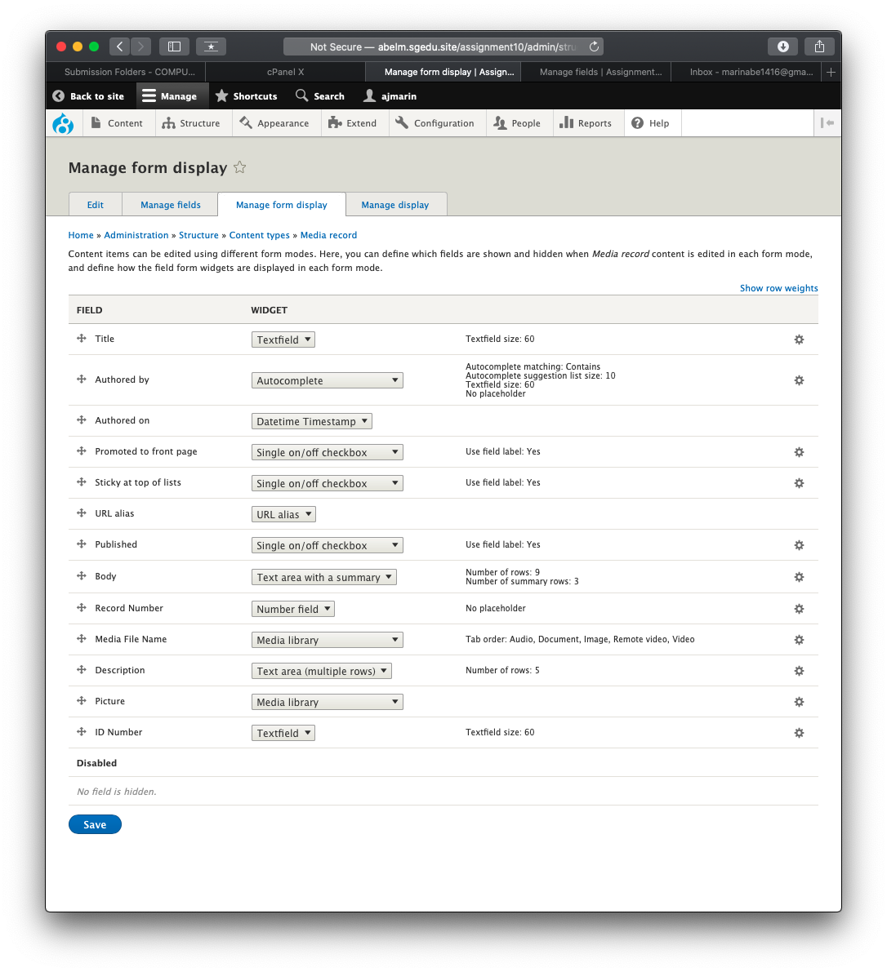] [D1.3]**

**[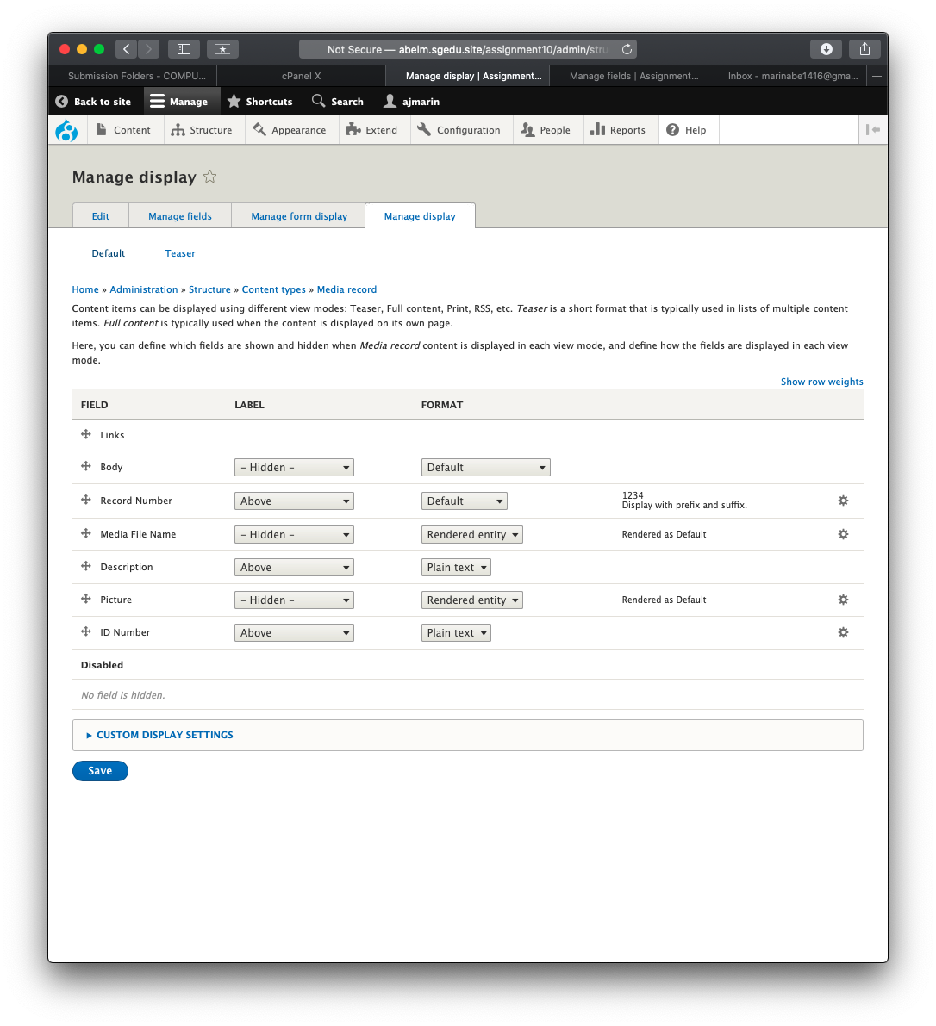] [D1.4]**

**Go back to the instructions and begin work on part E.**

**Part E: Add Media record Nodes - Records**

1. **SCREEN CAPTURE of the list of “Media record” nodes (records)  
    [**Admin toolbar > Content, filter by “Media record”] **[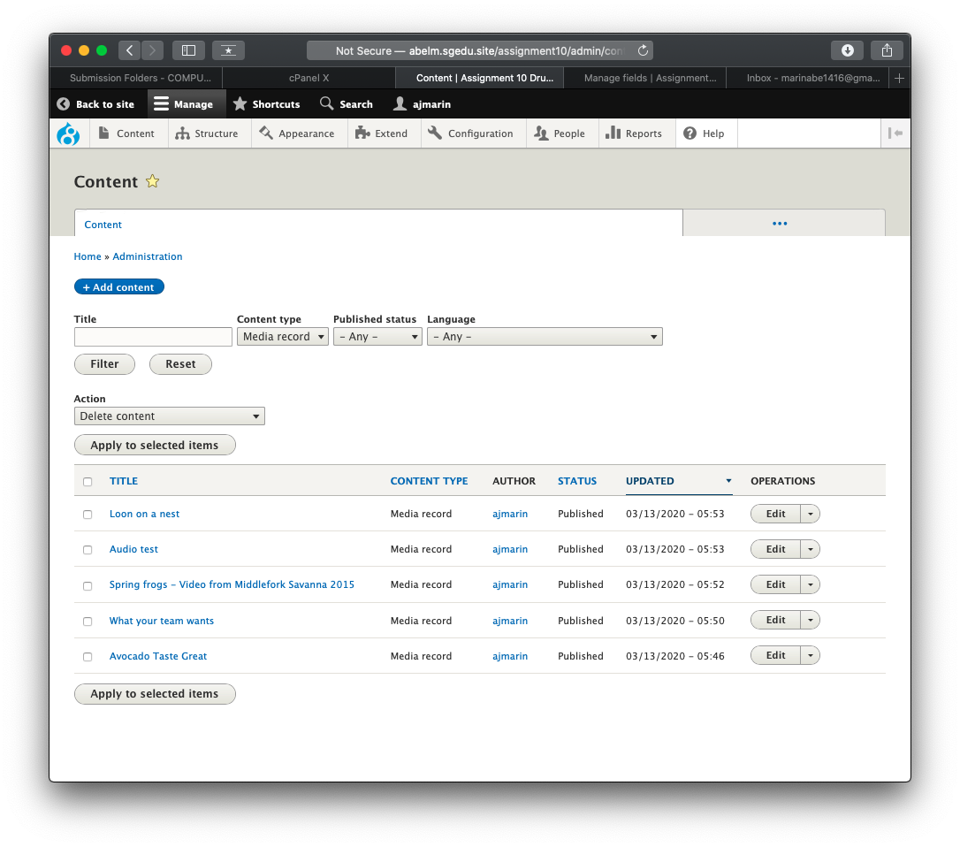] [E01]**
2. **SCREEN CAPTURE OF ONE Media - RECORD #1 [E02]**PLEASE EXPAND URL ALIAS AND PROMOTION OPTIONS BEFORE TAKING THE SCREEN CAPTURE.  
   USE AS MANY SCREEN CAPTURES AS IT TAKES TO DISPLAY THE WHOLE PAGE. **[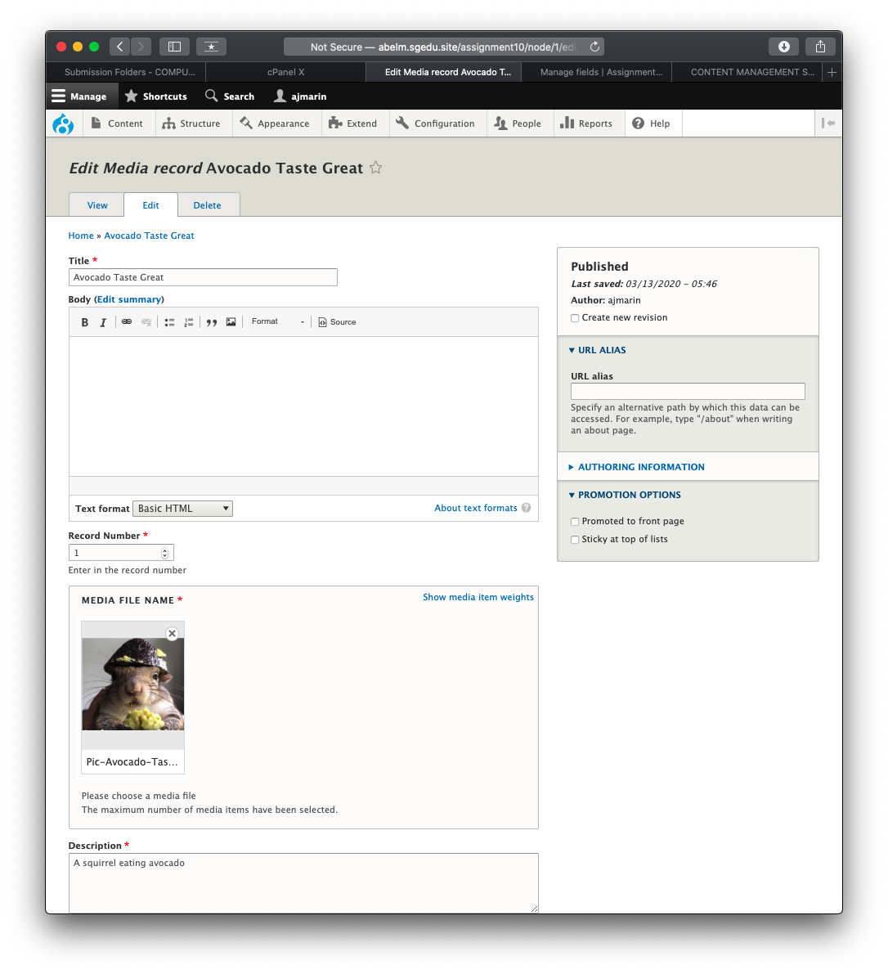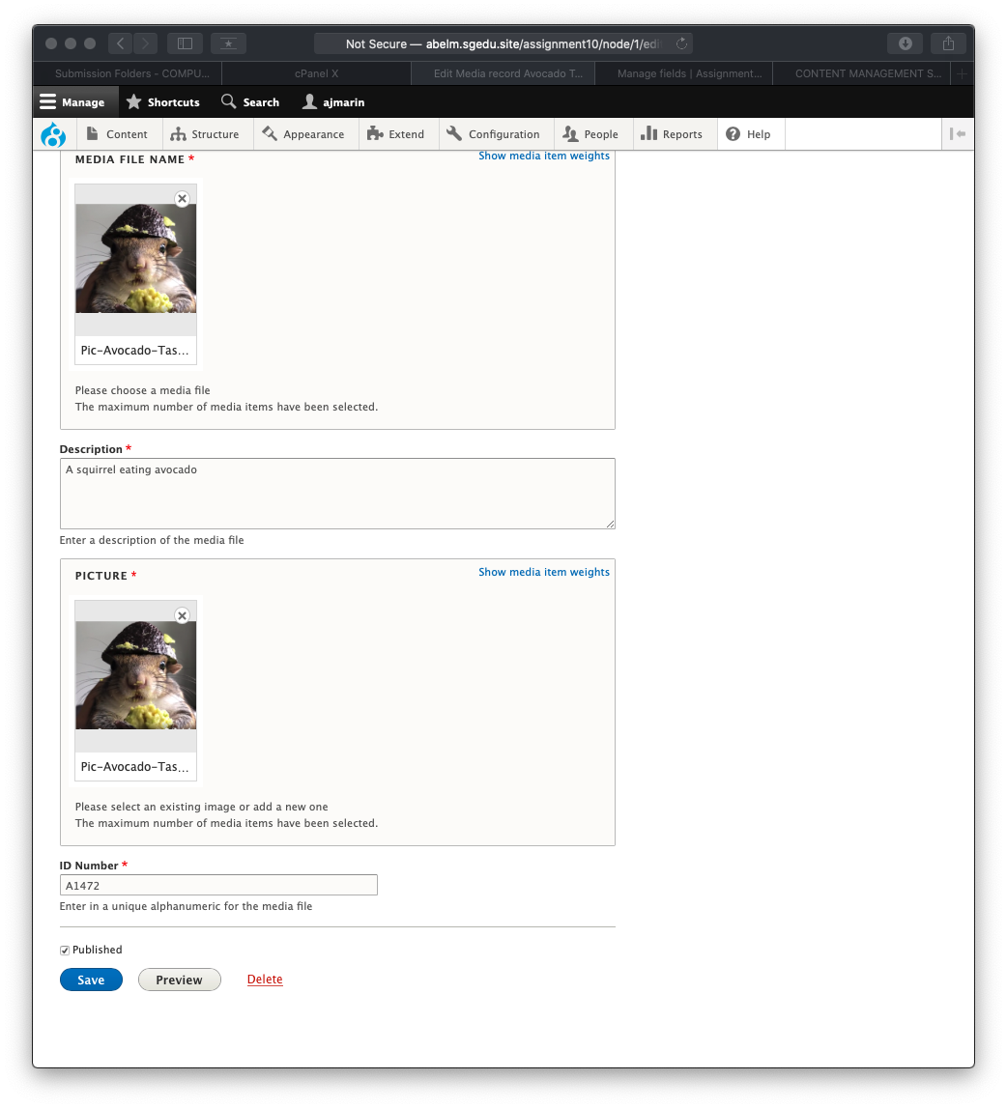]**
3. **SCREEN CAPTURE of one Media - Record #3 [E03]**Please expand URL alias and Promotion options before taking the screen capture.  
   Use as many screen captures as it takes to display the whole page. **[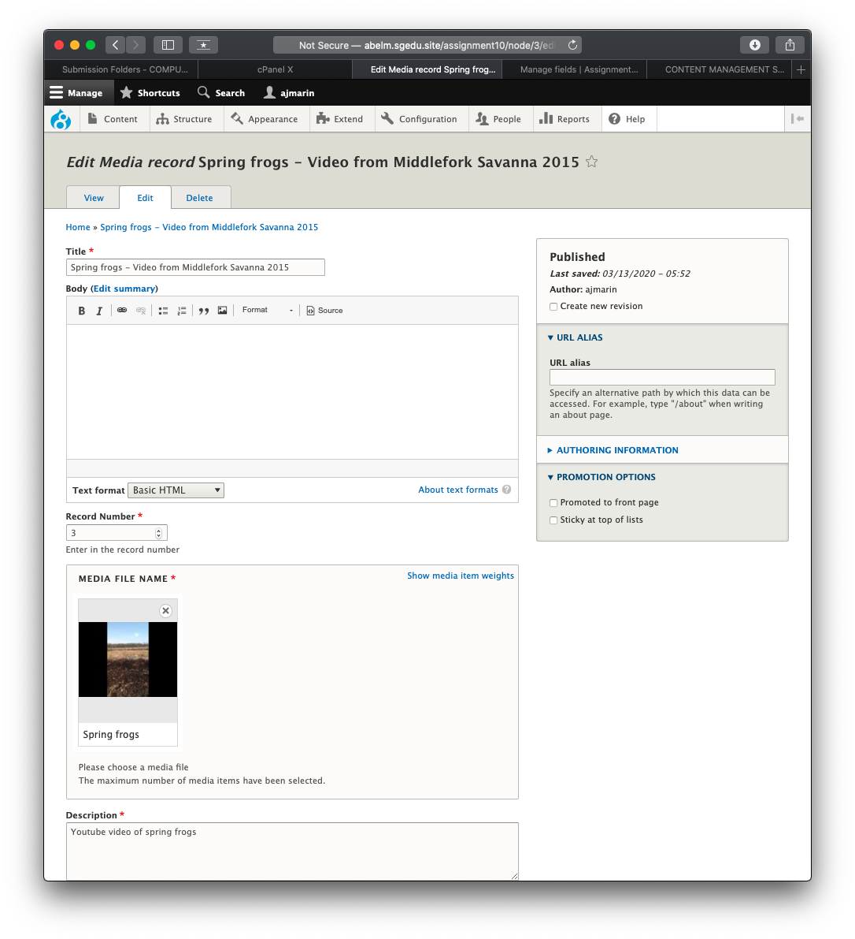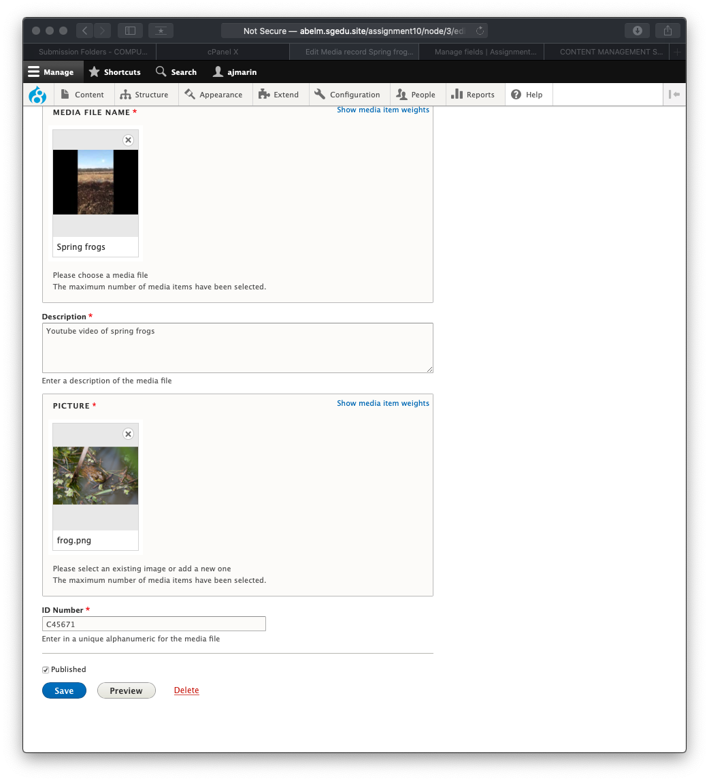]**
4. **SCREEN CAPTURE of one Photograph - Record #5 [E04]**Please expand URL alias and Promotion options before taking the screen capture.  
   Use as many screen captures as it takes to display the whole page. **[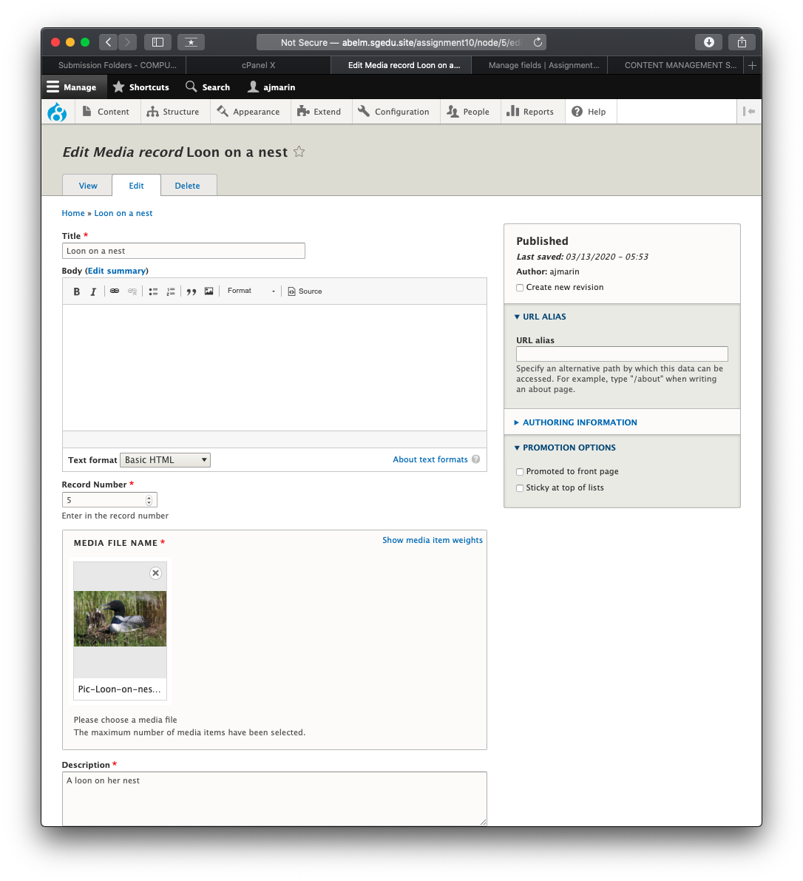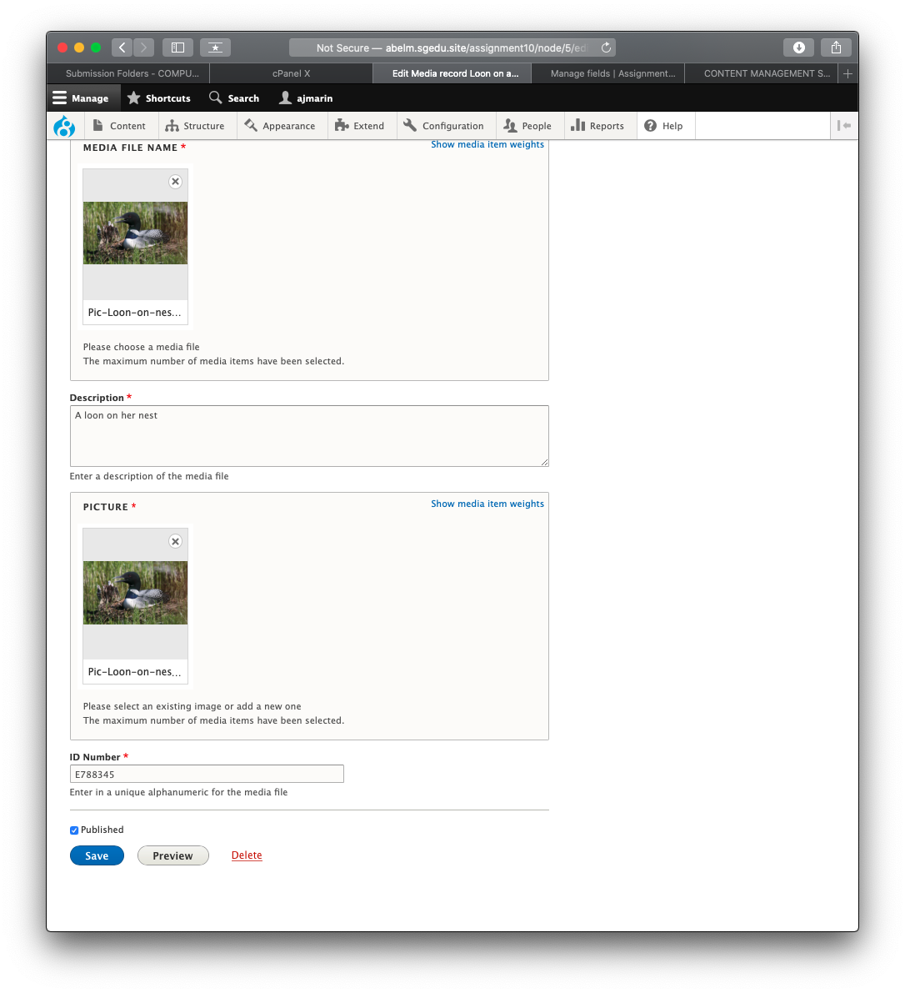]**

**Go back to the instructions and begin work on part F.**

**Part F: View**

1. SCREEN CAPTURE of the backend **view list with “**My media record view ” visible **[F01]  
   Admin toolbar > Structure > Views, with “**My media record view ” visible

**[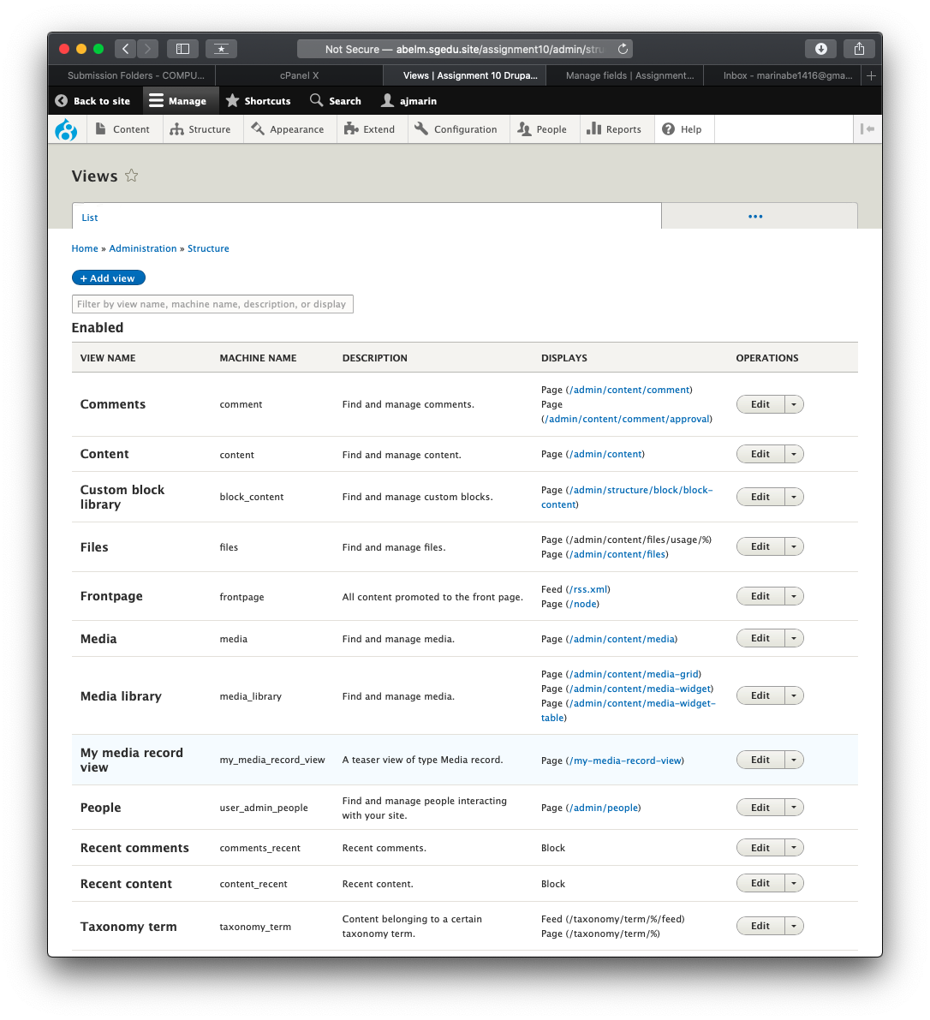]**

1. SCREEN CAPTURE of the backend **“**My media record view” summary page **[F02] [F03]  
   Admin toolbar > Structure > Views, Edit** My media record view  
   **[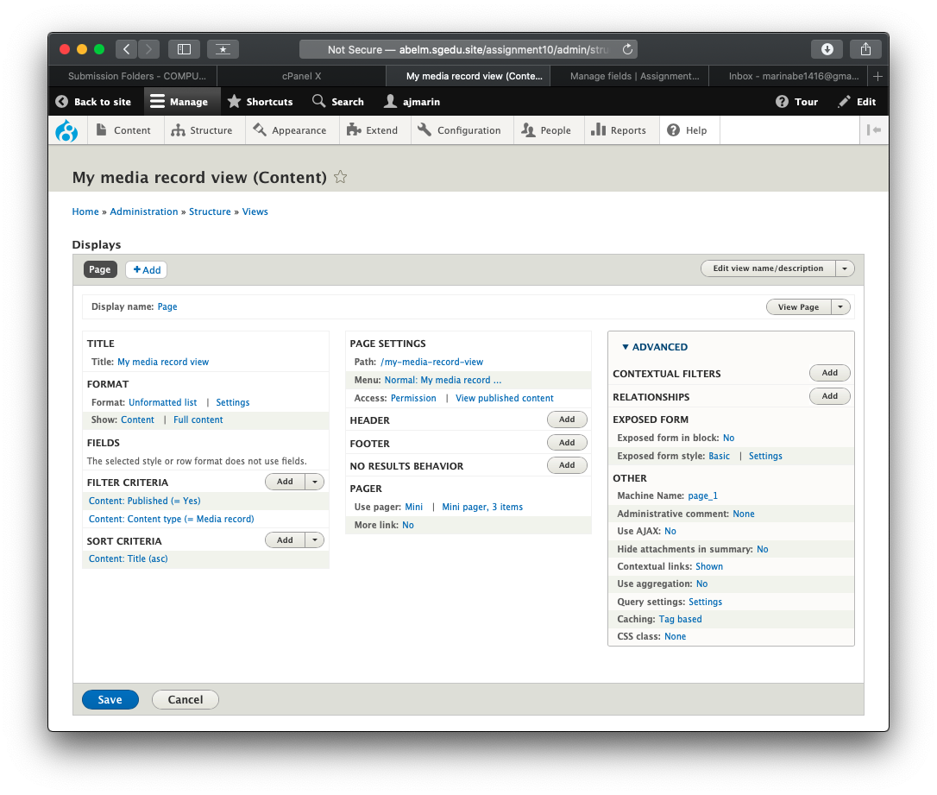]   
   [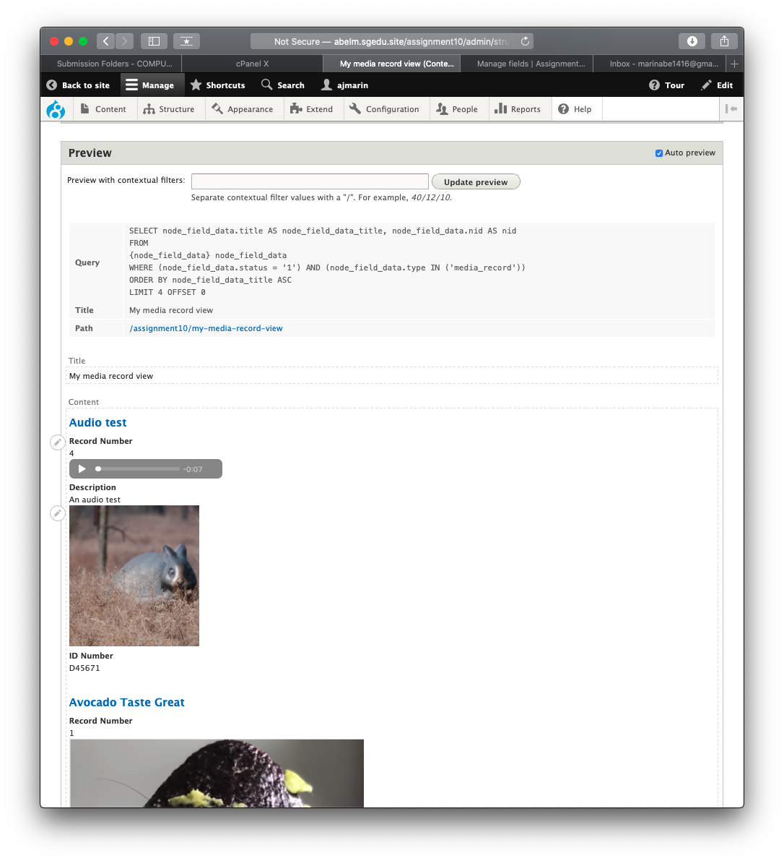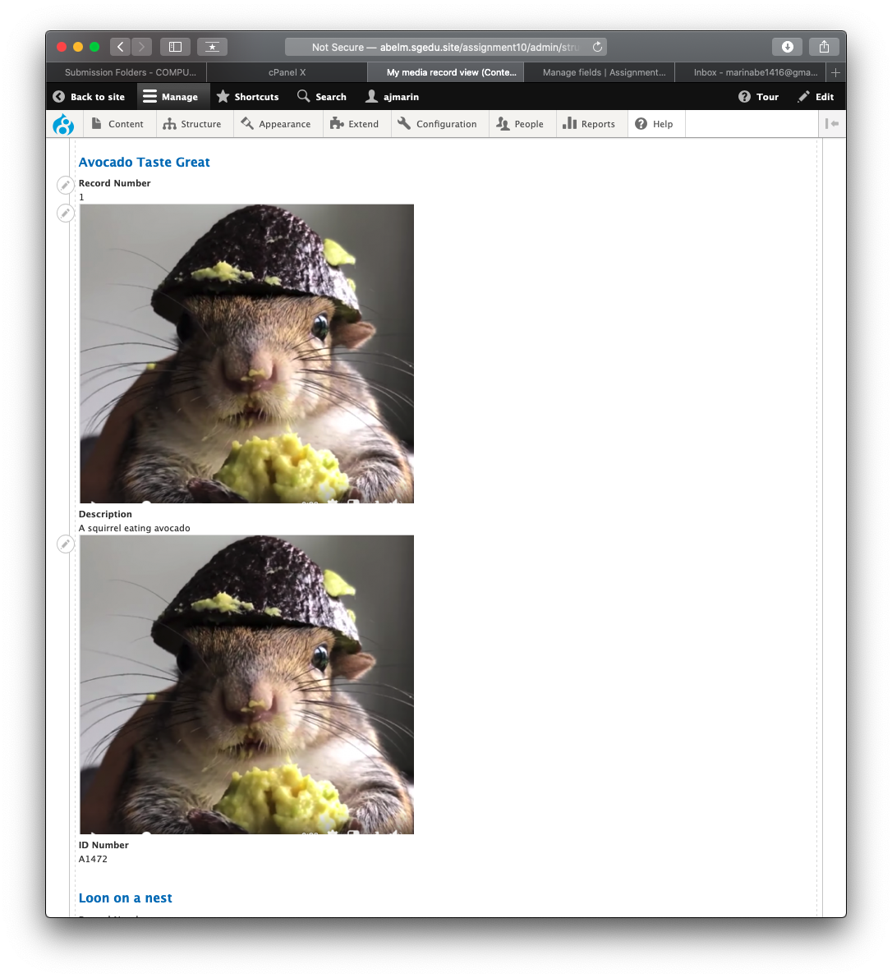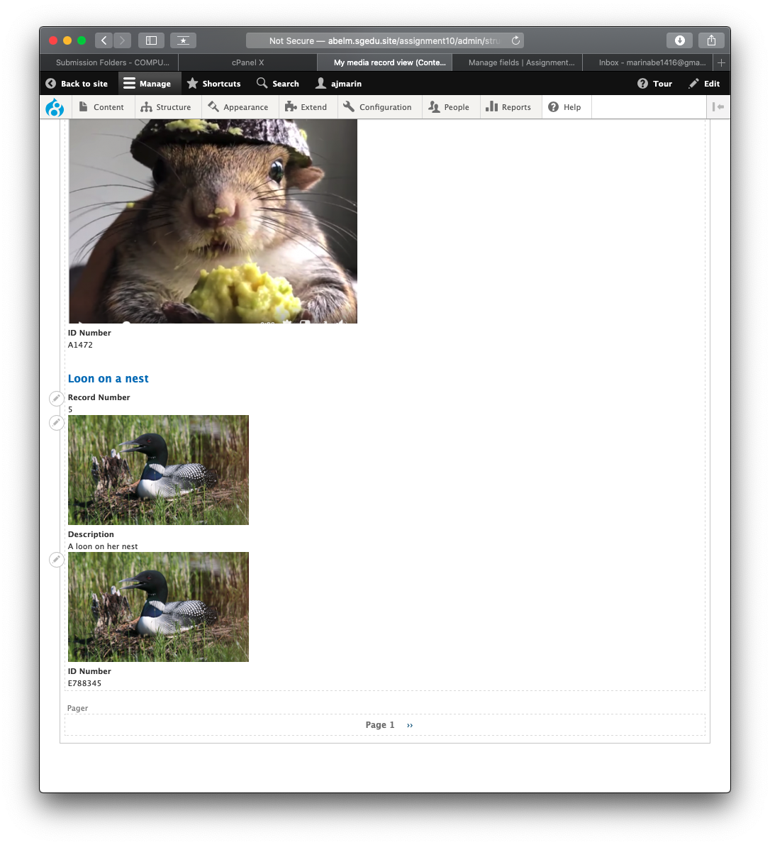]**
2. **SCREEN CAPTURE of the frontend** of the website showing the selected   
   “My media record view” main navigation menu option.   
   Take multiple screen captures to show output form page 1 and 2.  
   Please make sure the web browser address bar is visible in the first image as well as the View Pager control at the bottom of the page. You can use multiple screen captures if necessary. **[F04] [F05]  
   [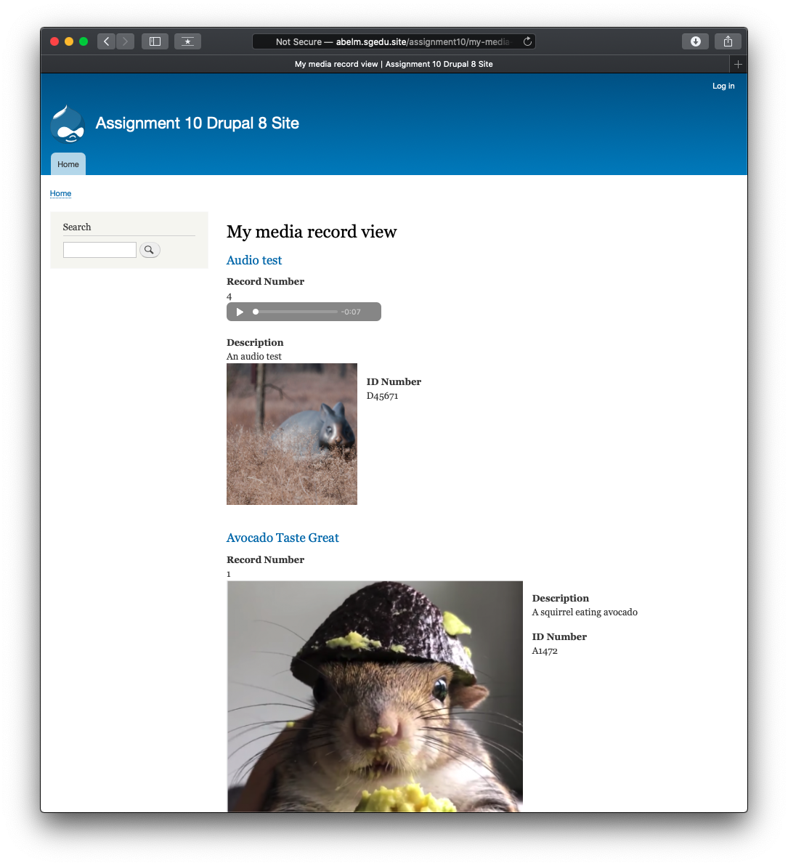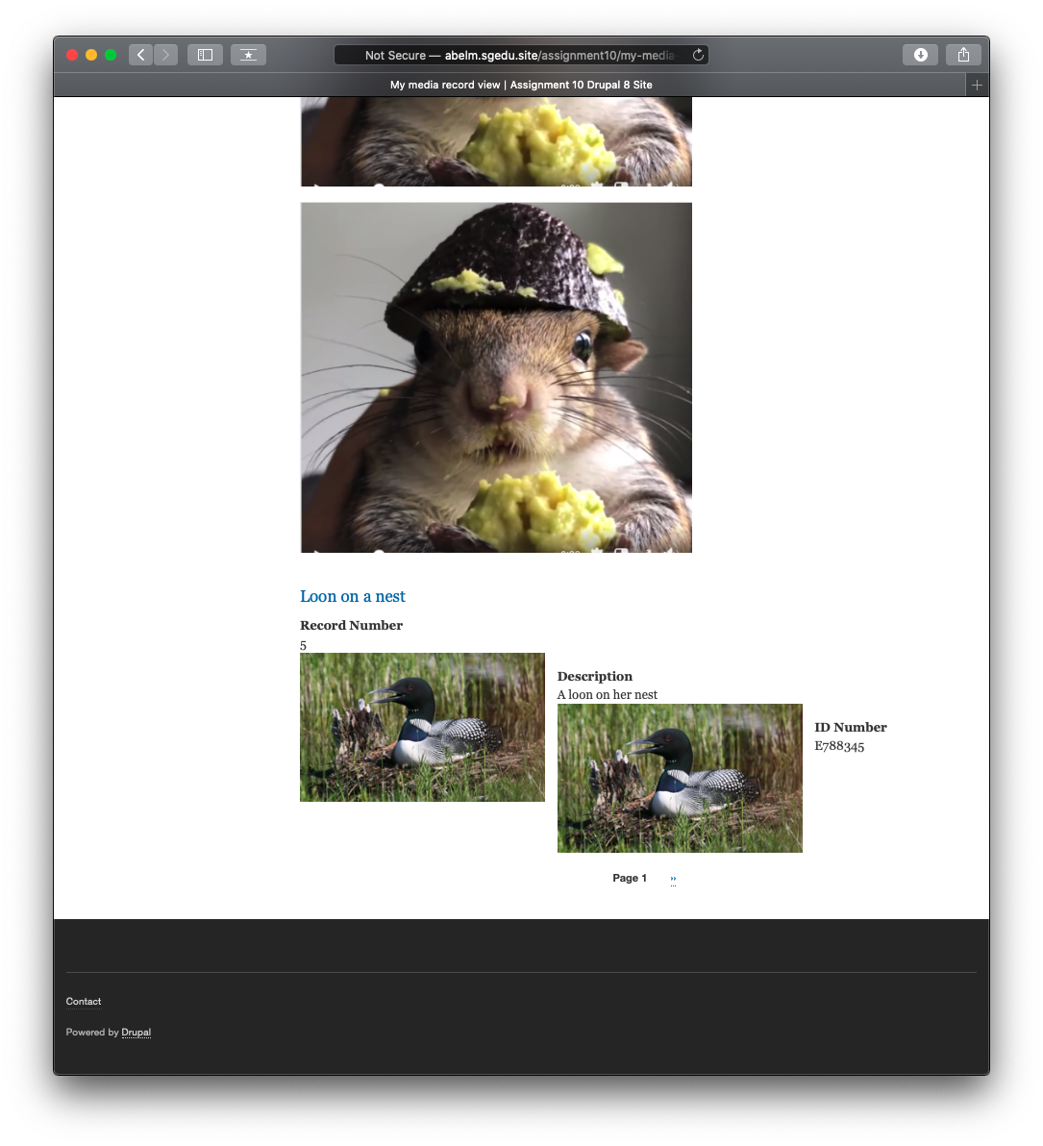]   
   [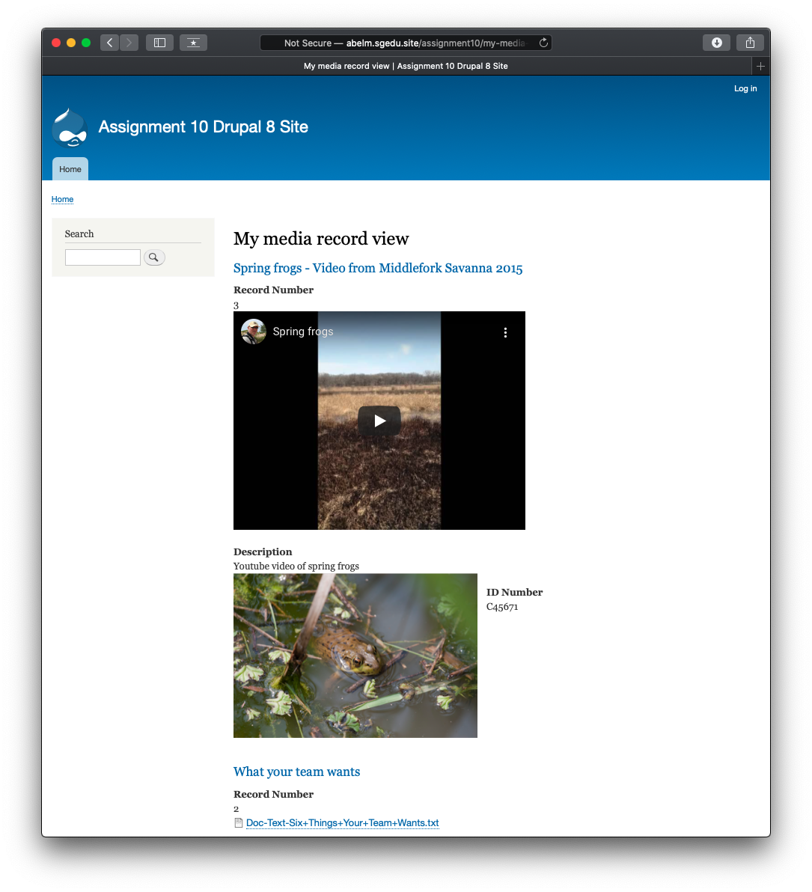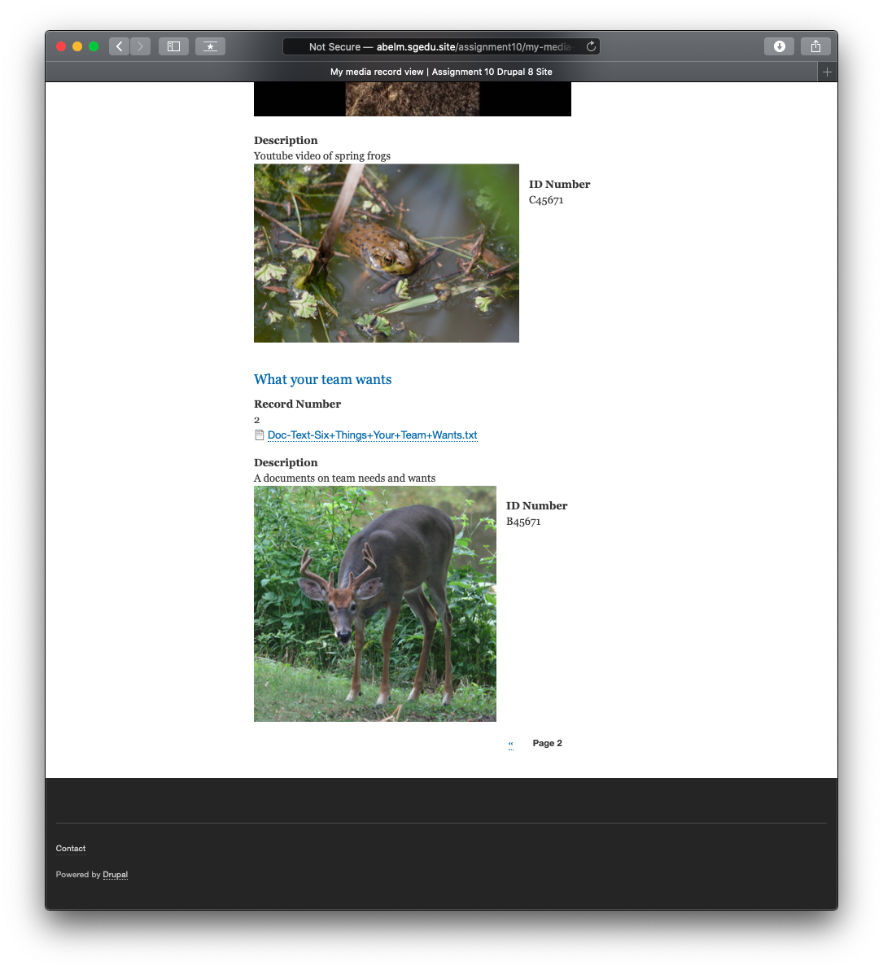]**

**Go back to the instructions and begin work on part G.**

**Part G – Add new Media Type - Instagram:**

1. Were you able to successfully add an Instagram Media type to your Drupal site? **[G01]**  
   **[Yes]**
2. If you were not successful, how far did you get and where did you run into difficulties? **[G02]**  
   **[I was successful and did not run into any difficulties.]**
3. If you were successful, what is the URL of your INSTAGRAM post **[G03]**  
   **[https://www.instagram.com/p/B3Fpmt6l1sV/?utm_source=ig_web_copy_link]**
4. Front End screen capture of the Basic page with the embedded Instagram post  
   **[G04]**  
   **[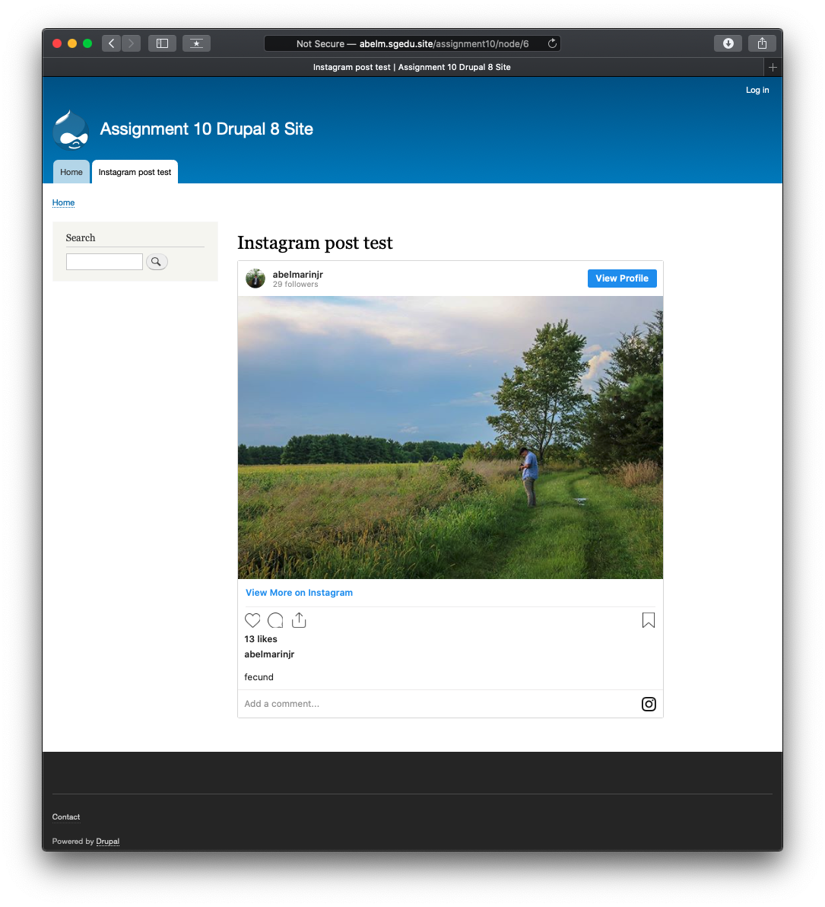]**

**Part H – Java Script libraries**

**Note:** The FlexSlider JS library and Module is required for the text Color buttons to work.

1. SCREEN CAPTURE of the cPanel File System Drupal 8 site folder with the libraries folder expanded and all its JS library folders visible **[H01]  
   [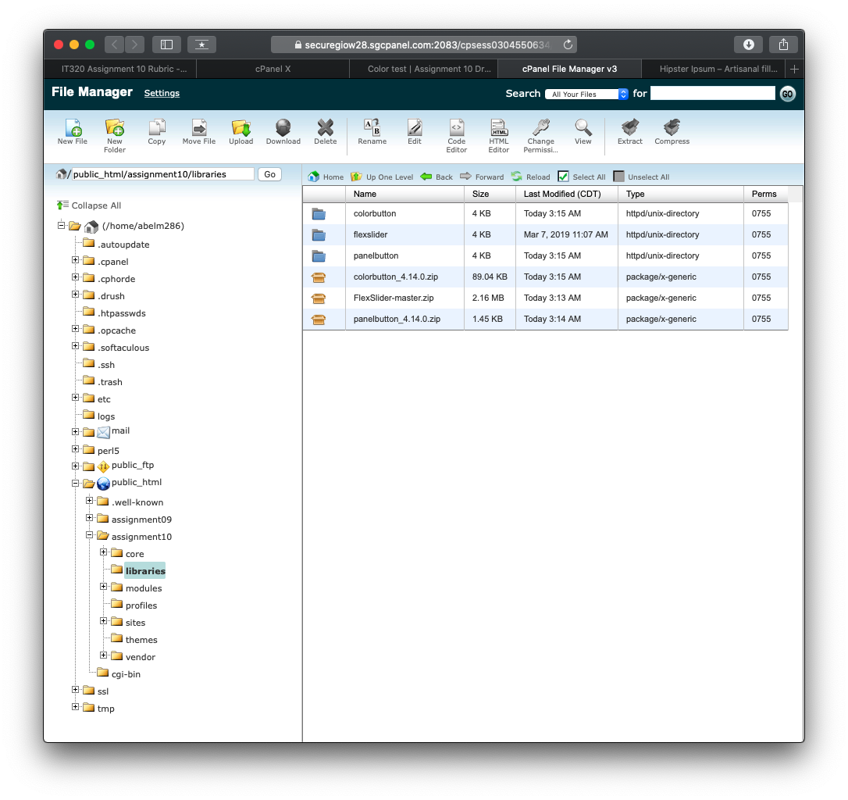]**
2. Backend screen capture the Extend page, filter for Color with the CKEditor Color visible **fully extended so the requires list is visible [H02]**  
   **[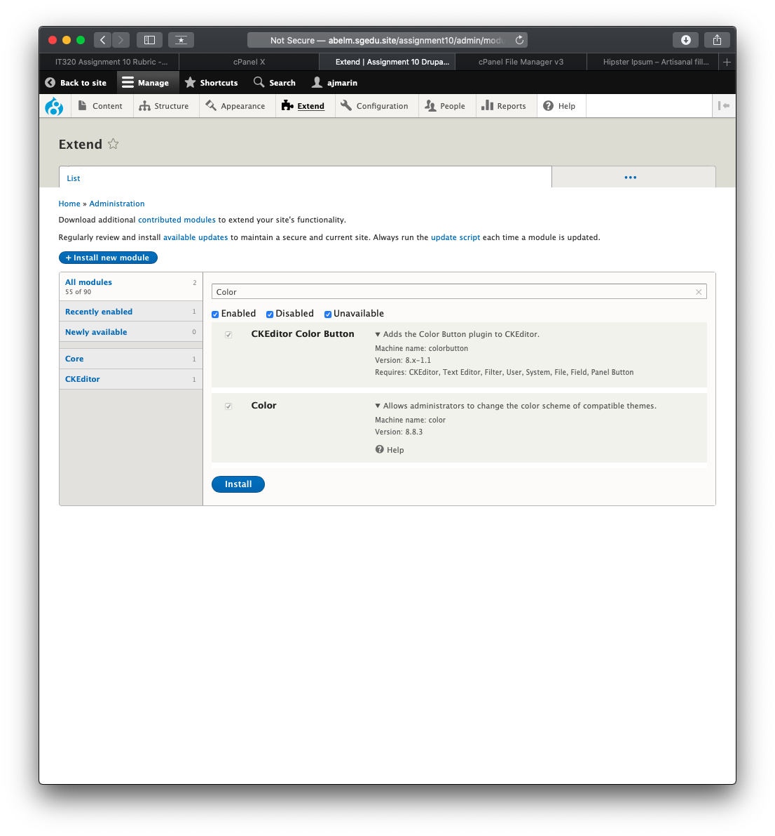]**
3. Backend screen capture the Full HTML toolbar with the Text Color and Background Color Button added to the Active Toolbar

**Admin toolbar > Configuration > CONTENT AUTHORING > Text formats and Editors [H03]**  
**[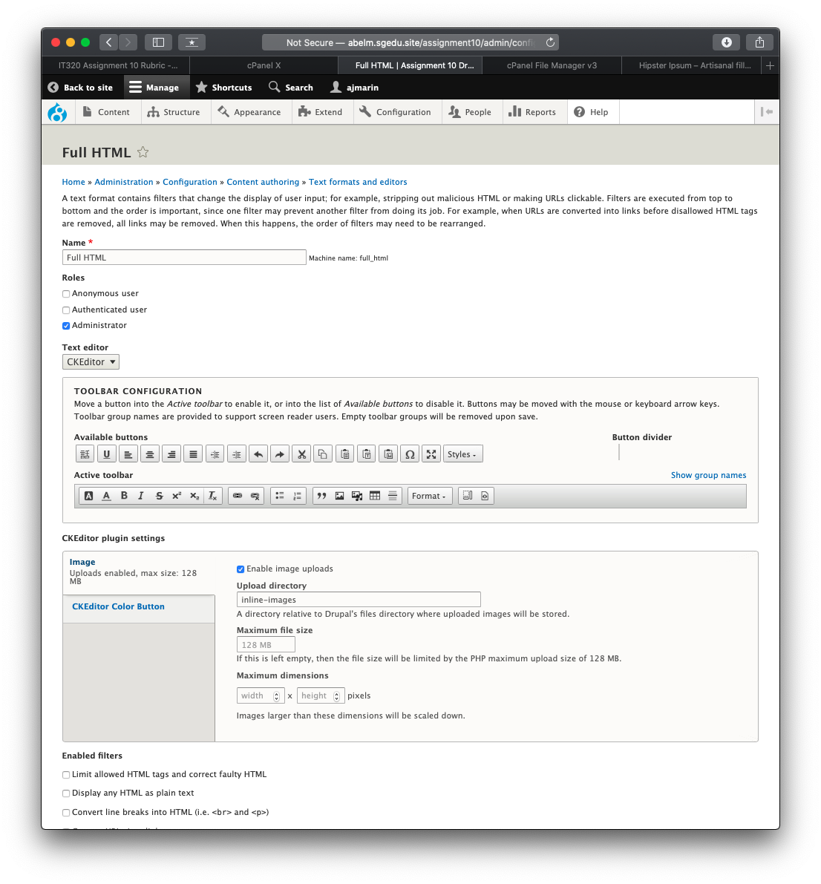]**

1. Front End screen capture of the Color Test Basic page with the web browser address bar visible **[H04]**  
   **[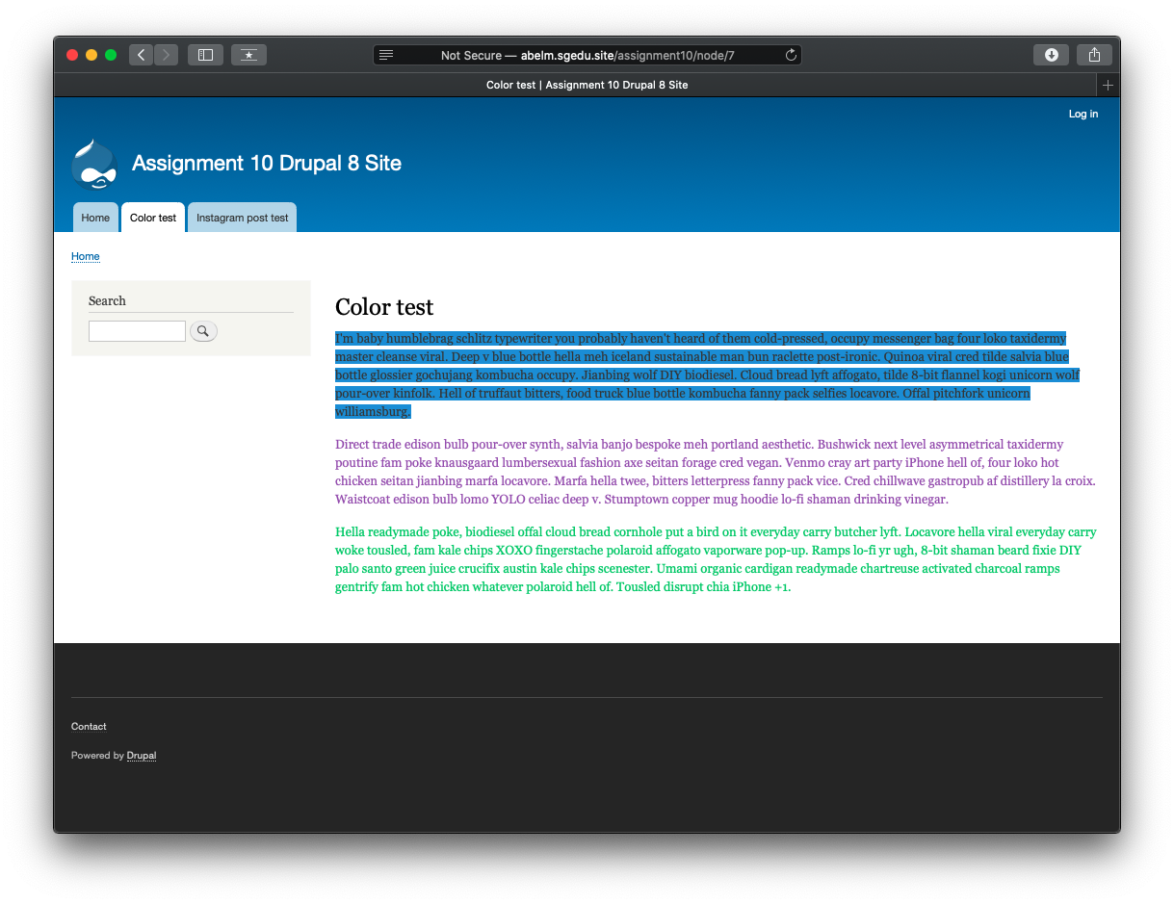]**

**Part I– Assignment Wrap up:**

Submit this completed template to the D2L assignment 09 dropbox.If you prefer not to navigate by hand to the D2L dropbox, take advantage of the dropbox link in the D2L current Assignment section. This link will take you to the correct assignment dropbox location.